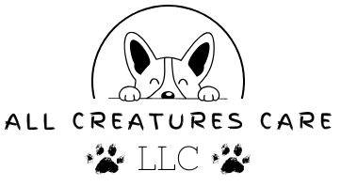
Dog Walking Agreement
Client: ____________________________________ Date: ___________________
We are glad that you have chosen All Creatures Care to walk your beloved dog. Ensuring the well-being and exercise of your furry family member is our top priority. This document outlines the terms and conditions of our dog walking services.
1. DOG INFORMATION:
- Dog's Name: ___________________________________________________________________
- Breed: ________________________________________________________________________
- Age: __________________________________________________________________________
- Special Walking Requirements (if any): ______________________________________________
- Medications, Medical Conditions or Allergies (if any): __________________________________
2. VETERINARY CARE:
- Veterinarian's Name & Office Number: ______________________________________________
3. WALKING SCHEDULE:
- Regular Walking Days: ___________________________________________________________
- Regular Walking Times: __________________________________________________________
- Walk Duration: __________________________________________________________________
4. EMERGENCY CONTACT:
- In case of emergency or unforeseen circumstances, please provide us with an emergency contact person and their contact information.
- Name, Phone Number & Relation: ___________________________________________________
5. HOME ACCESS INFORMATION:
- Key Provided: □ Yes □ No
- Access Instructions: _______________________________________________________________
- Alarm Code (if applicable): _________________________________________________________
6. WALKING FEES:
- Walking fees will be calculated based on frequency, duration, and any additional services requested. Payment is due at the time of service. We accept Cash, Venmo, Zelle, & Apple Pay.
7. RELEASE OF LIABILITY:
- While we make every effort to ensure the safety and well-being of your dog during walks, All Creatures Care cannot be held responsible for any injury, illness, or loss of your dog that may occur during the walking period. This includes, but is not limited to, accidents, injuries, escapes, or interactions with other animals. By signing below, you acknowledge and accept this disclaimer.
Client's Signature: __________________________________________ Date: __________________

