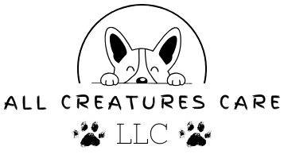
Pet Boarding Agreement
Client: ___________________________________ Date: ___________________
We are delighted that you have chosen All Creatures Boarding to care for your beloved pet during their overnight stay. Ensuring the well-being and comfort of your furry family member is our top priority. This document outlines the terms and conditions of our boarding services.
- PET INFORMATION:
  - Pet's Name: _______________________________________________________________
  - Breed:____________________________________________________________________
  - Age:______________________________________________________________________
  - Special Dietary Requirements (if any): __________________________________________
  - Medical Conditions or Allergies (if any): _________________________________________
  - Medications (if any):_________________________________________________________

- VETERINARY CARE:
  - Veterinarians Name & Office Number___________________________________________

- DROP-OFF AND PICK-UP:
  - Drop-off Date and Time:______________________________________________________
  - Pick-up Date and Time:_______________________________________________________

- EMERGENCY CONTACT:
  - In case of emergency or unforeseen circumstances, please provide us with an emergency contact person and their contact information.
    - Name & Phone Number:______________________________________________

- FEEDING AND MEDICATION:
  - Please provide enough food for your pet's stay. If your pet requires specific feeding instructions or medications, provide clear written instructions, dosage, and the medication itself in the original packaging.
- BOARDING FEES:
  - Boarding fees will be calculated based on the length of stay and any additional services requested. Payment is due at the time of pickup. We accept Cash, Venmo, Zelle, & Apple Pay.
- RELEASE OF LIABILITY
  - While we make every effort to ensure the safety and well-being of your pet during their stay, All Creatures Boarding cannot be held responsible for any injury, illness, or loss of your pet that may occur during the boarding period. This includes, but is not limited to, accidents, illnesses, escapes, or interactions with other animals. By signing below, you acknowledge and accept this disclaimer.

Client's Signature: __________________________________________ Date: __________________
Thank you for entrusting us with the care of your cherished pet. If you have any questions or require further assistance, please do not hesitate to contact us.
Sincerely,
Miranda Misenko

